HC 1 T1 U1
 | 題目 | 圖片
1 | What is it?  It's a book. | 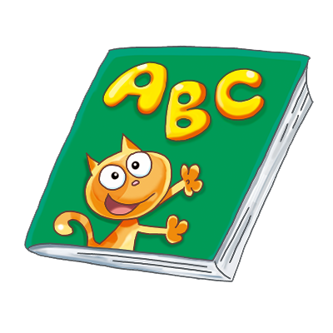
2 | What is it?  It's a bag. | 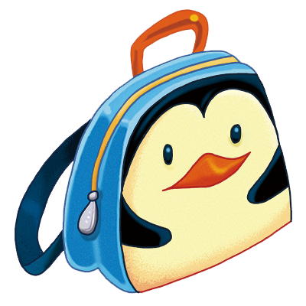
3 | What is it?  It's a hat. | 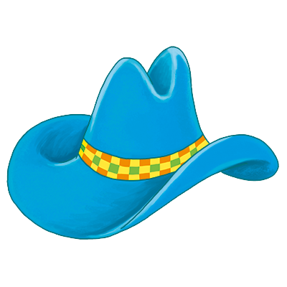
4 | What is it?  It's a cup. | 